192110057-C.Nanda Kishore Reddy

1.FACTORIAL OF THE GIVEN NUMBER:

2.FINDING GIVEN NUMBER IS ARMSTRONG OR NOT:

3.SUMMING UP THE DIGITS OF AN INTEGER:

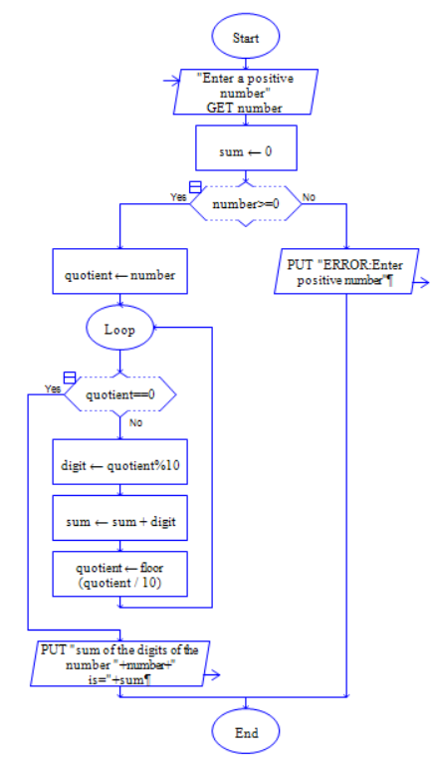

4.REVERSE THE DIGITS OF AN INTEGER NUMBER:

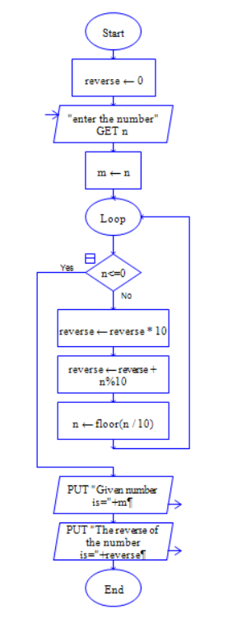

5.FINDING THE GIVEN INTEGER IS POSITIVE OR NEGATIVE:

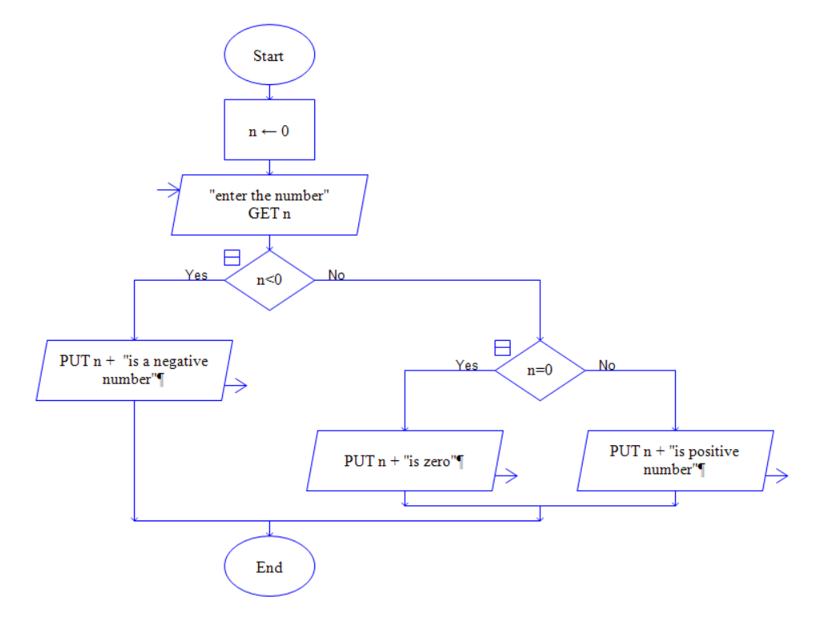

6.SWAPPING TWO NUMBERS WITH A TEMPORARY VARIABLE:

7.FIBONACCI SERIES:

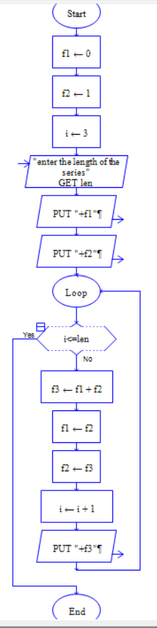

8.SUMMING UP ANY N NUMBERS AND FINDING AVERAGE:

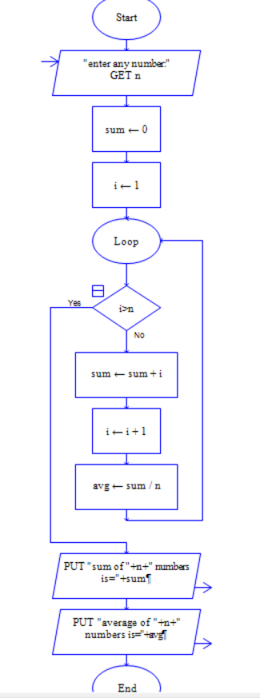

9.PRINTING DIGITS OF AN INTEGER NUMBER:

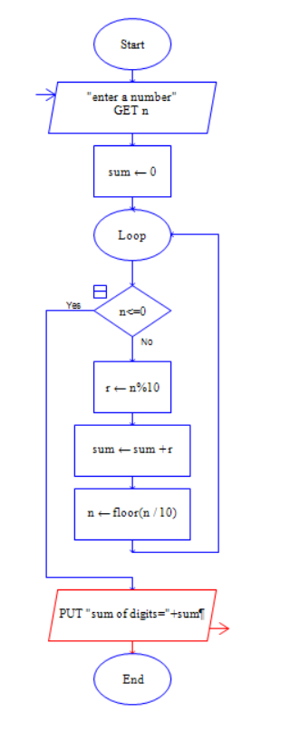

10.FINDING WHETHER THE GIVEN INTEGER IS EVEN OR ODD:

